NDNL is processeto clean the vessel by cancelling bookings which customers have failed to submit the document as well as container against their shipments. GBSI CR team will clean the Dry bookings only (20ST/40ST/40HC/Tank/45HC).

**Applications used for NDNL task:**

1. Vessel schedule file.
2. CCA Reports access - <https://ccainternal.america.cma-cgm.com/ccareports/index.php>
3. Outlook

**Starting with the Vessel Schedule file,**

1. Open the excel file
2. Put the filter in row number 2
3. Go to column G 🡪 select blank 🡪 delete all blank + Summary and date row 🡪 Remove filter
4. Apply filter 🡪 Go to column G 🡪 Select APL vessel 🡪 Delete them from the list 🡪 Remove filter
5. Apply filter 🡪 Go to column J 🡪 Select today’s cut-off date.
6. We will need to action all the voyages reflected in column G.
7. One by one we will extract the NDNL report.

**CCA Reports: Login to CCA report site**

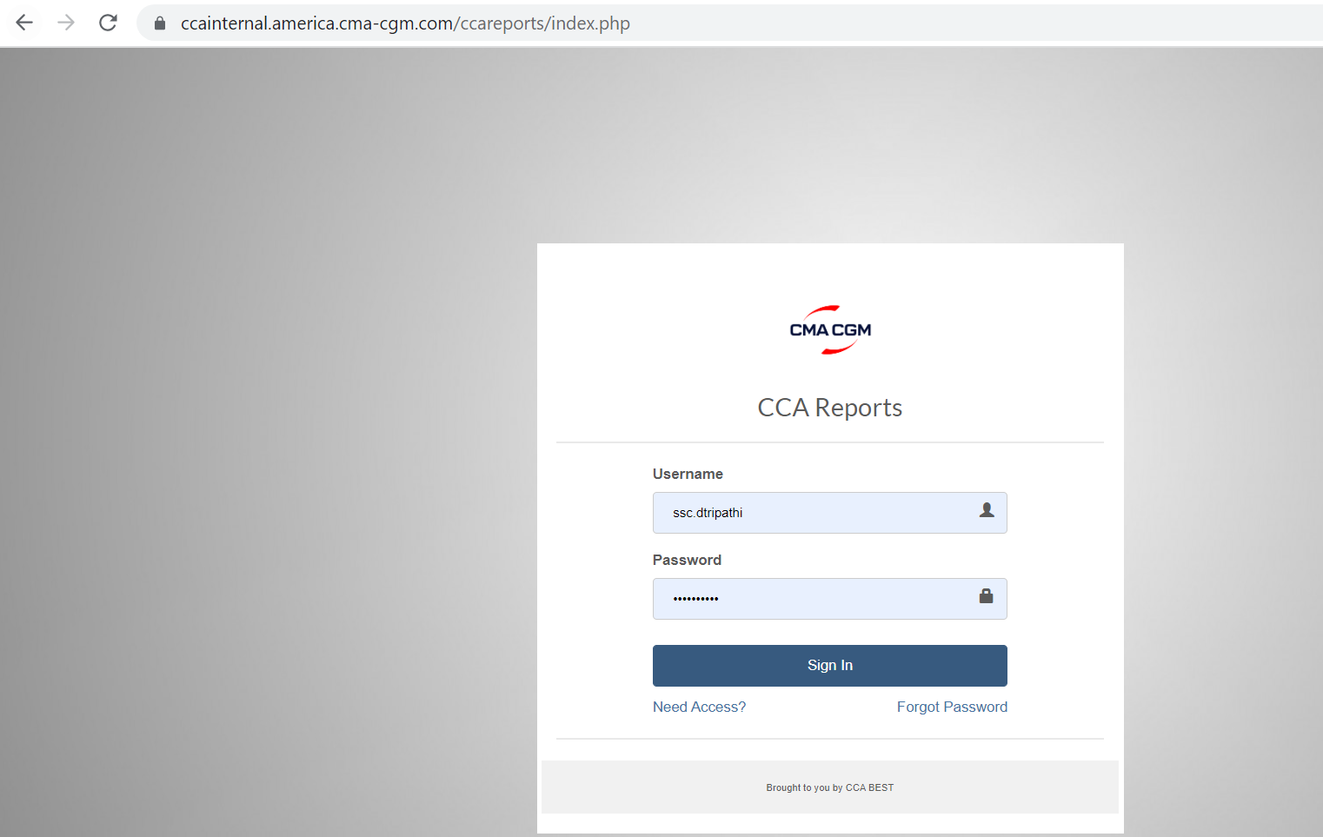

Once you login to the site click on Reports 🡪 under drop down select No Doc No Load. Below image for reference.

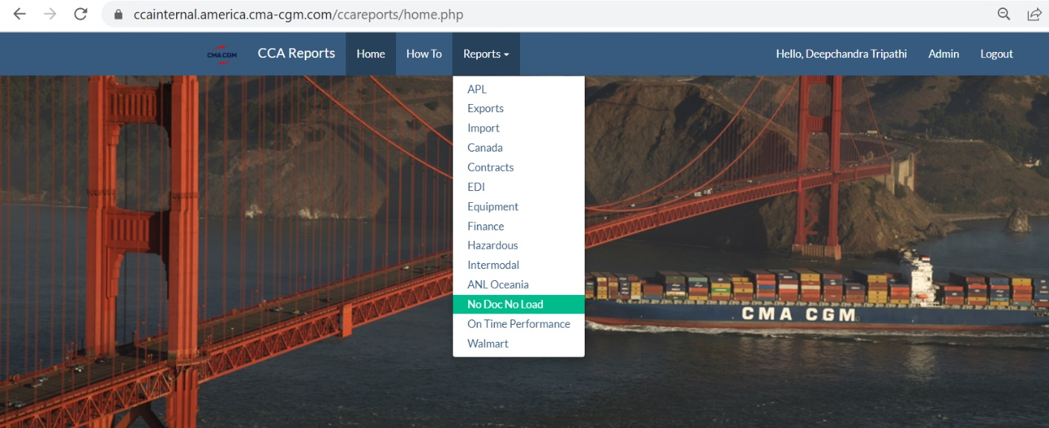

After selecting NDNL report below page will appear.

Note: We will have to type the voyage number in the drop down and select the correct one.

Click on No Doc No Load 🡪 file will get downloaded in the system.

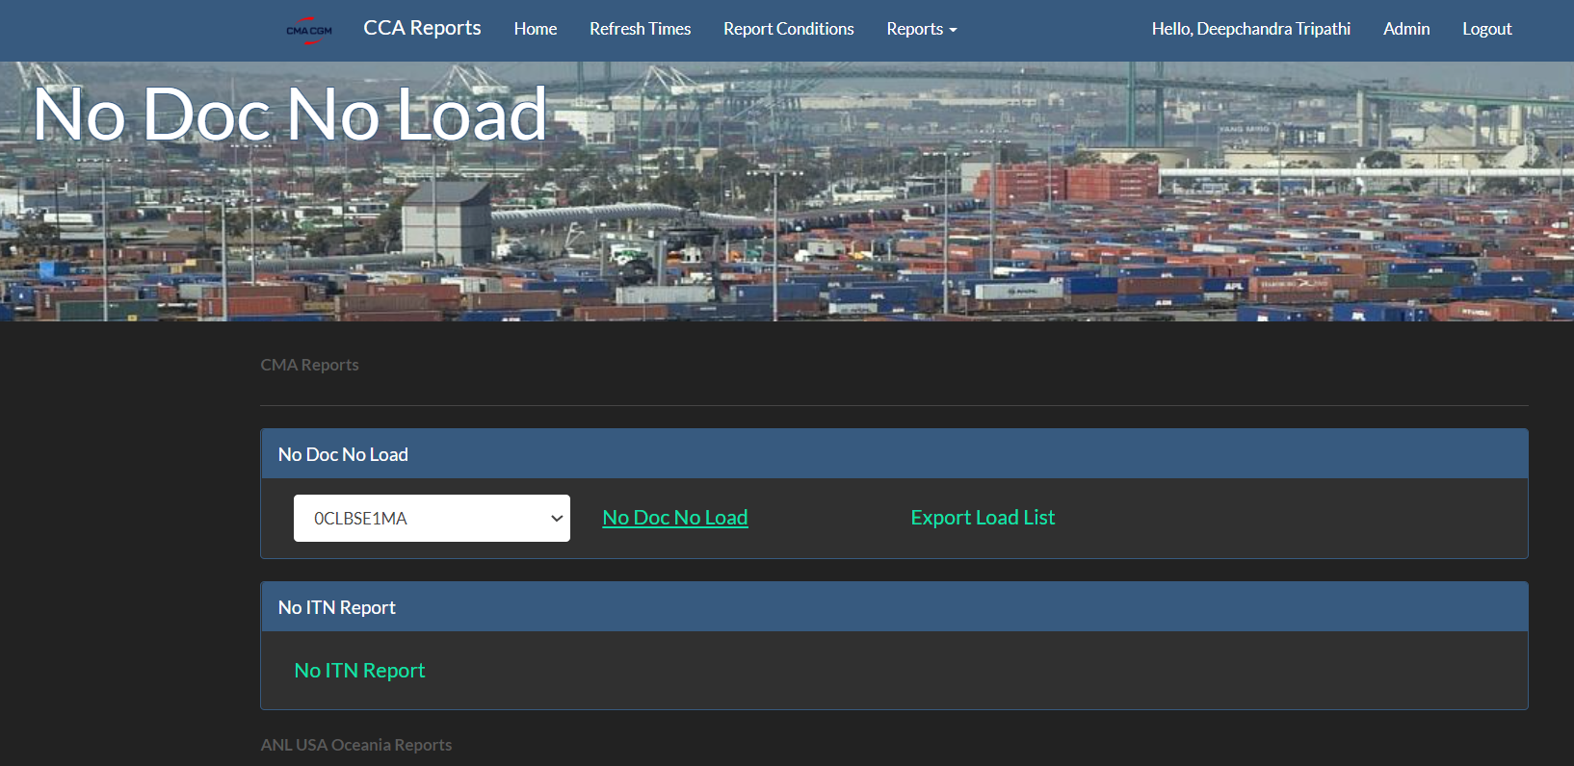

**NDNL sheet:**

1. Apply filter in row no. 3
2. Go to Column “AC” and select 0
3. Column “Z” 🡪 we will select only Dry containers excluding all the special containers (OT, Reefer, Flat rack)
4. **Go to Column “O” and select the POL as per vessel schedule file.**

**Some time there will be multiple POL so always select the appropriate one to avoid errors**.

1. After doing the above selection we will action all the shipments from column “A”.
2. These bookings will be actioned by the BOT and not by GBSI.
3. We will have to send email to BOT ([booking-cancelations@cma-cgm.com](mailto:booking-cancelations@cma-cgm.com)) with all the booking numbers and reason.
4. We will get confirmation from the BOT whether it has been actioned or not.